Chapter 11, Solution 61.

Consider the network shown below.
S₁
S₃
S₂
I_{o}
+
V_{o}
−
I₁
S_{o}
I₂

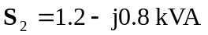

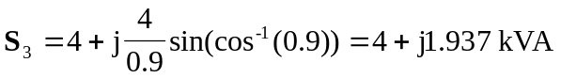

Let 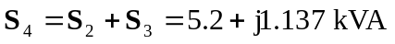
But 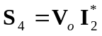

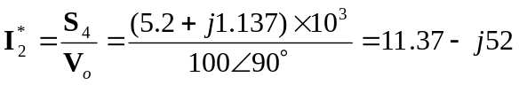
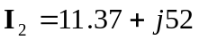

Similarly, 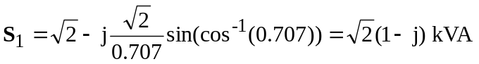
But 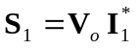

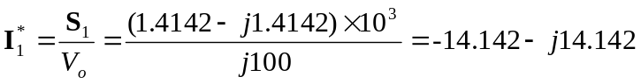
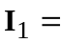 – 14.142 + j14.142

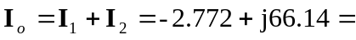 66.2∠92.4° A

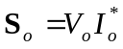
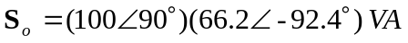

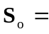6.62∠–2.4° kVA

66.2∠92.4° A, 6.62∠–2.4° kVA

